PL/SQL PROGRAMMING:

EXERCISE 1: CONTROL STRUCTURES

SET SERVEROUTPUT ON;

BEGIN

EXECUTE IMMEDIATE 'DROP TABLE loans';

EXECUTE IMMEDIATE 'DROP TABLE customers';

EXCEPTION

WHEN OTHERS THEN NULL;

END;

/

CREATE TABLE customers (

customer_id NUMBER PRIMARY KEY,

name VARCHAR2(100),

age NUMBER,

balance NUMBER,

is_vip CHAR(1) DEFAULT 'N'

);

CREATE TABLE loans (

loan_id NUMBER PRIMARY KEY,

customer_id NUMBER,

due_date DATE,

interest_rate NUMBER

);

INSERT INTO customers VALUES (1, 'Arun', 65, 15000, 'N');

INSERT INTO customers VALUES (2, 'Kavita', 45, 8000, 'N');

INSERT INTO customers VALUES (3, 'Mani', 70, 12000, 'N');

INSERT INTO loans VALUES (101, 1, SYSDATE + 10, 7.5);

INSERT INTO loans VALUES (102, 2, SYSDATE + 40, 6.8);

INSERT INTO loans VALUES (103, 3, SYSDATE + 5, 8.2);

COMMIT;

Scenario 1: Apply 1% discount to interest rates for customers age > 60

BEGIN

FOR rec IN (SELECT l.loan_id, c.age

FROM loans l

JOIN customers c ON l.customer_id = c.customer_id)

LOOP

IF rec.age > 60 THEN

UPDATE loans

SET interest_rate = interest_rate - 1

WHERE loan_id = rec.loan_id;

END IF;

END LOOP;

COMMIT;

DBMS_OUTPUT.PUT_LINE('Interest rate discount applied for age > 60.');

END;

/

Scenario 2: Set IsVIP flag for balance > 10,000

BEGIN

FOR rec IN (SELECT customer_id, balance FROM customers)

LOOP

IF rec.balance > 10000 THEN

UPDATE customers

SET is_vip = 'Y'

WHERE customer_id = rec.customer_id;

END IF;

END LOOP;

COMMIT;

DBMS_OUTPUT.PUT_LINE('VIP status set for customers with balance > 10000.');

END;

/

Scenario 3: Print reminders for loans due in next 30 days

BEGIN

FOR rec IN (

SELECT l.loan_id, l.due_date, c.name

FROM loans l

JOIN customers c ON l.customer_id = c.customer_id

WHERE l.due_date <= SYSDATE + 30

)

LOOP

DBMS_OUTPUT.PUT_LINE('Reminder: Loan ID ' || rec.loan_id ||

' for customer ' || rec.name ||

' is due on ' || TO_CHAR(rec.due_date, 'DD-Mon-YYYY'));

END LOOP;

END;

/

OUTPUT:

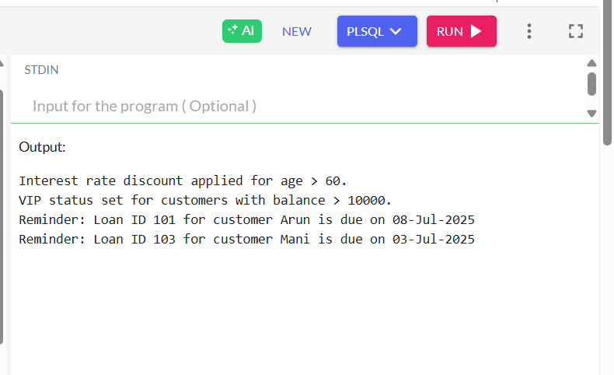

SET SERVEROUTPUT ON;

BEGIN

EXECUTE IMMEDIATE 'DROP TABLE accounts';

EXECUTE IMMEDIATE 'DROP TABLE employees';

EXCEPTION

WHEN OTHERS THEN NULL;

END;

/

CREATE TABLE accounts (

account_id NUMBER PRIMARY KEY,

customer_name VARCHAR2(100),

balance NUMBER,

account_type VARCHAR2(20)

);

CREATE TABLE employees (

employee_id NUMBER PRIMARY KEY,

name VARCHAR2(100),

department VARCHAR2(50),

salary NUMBER

);

INSERT INTO accounts VALUES (1, 'John Doe', 10000, 'savings');

INSERT INTO accounts VALUES (2, 'Jane Smith', 5000, 'savings');

INSERT INTO accounts VALUES (3, 'Mike Brown', 3000, 'current');

INSERT INTO employees VALUES (101, 'Alice', 'HR', 50000);

INSERT INTO employees VALUES (102, 'Bob', 'IT', 60000);

INSERT INTO employees VALUES (103, 'Charlie', 'IT', 55000);

COMMIT;

Scenario 1 - Monthly Interest Procedure

CREATE OR REPLACE PROCEDURE ProcessMonthlyInterest AS

BEGIN

FOR acc IN (SELECT account_id, balance FROM accounts WHERE account_type = 'savings') LOOP

UPDATE accounts

SET balance = balance + (acc.balance * 0.01)

WHERE account_id = acc.account_id;

END LOOP;

COMMIT;

DBMS_OUTPUT.PUT_LINE('Monthly interest of 1% applied to all savings accounts.');

END;

/

Scenario 2 - Bonus Procedure

CREATE OR REPLACE PROCEDURE UpdateEmployeeBonus (

dept_name IN VARCHAR2,

bonus_percent IN NUMBER

) AS

BEGIN

UPDATE employees

SET salary = salary + (salary * bonus_percent / 100)

WHERE department = dept_name;

COMMIT;

DBMS_OUTPUT.PUT_LINE('Bonus of ' || bonus_percent || '% applied to department: ' || dept_name);

END;

/

Scenario 3 - Fund Transfer Procedure

CREATE OR REPLACE PROCEDURE TransferFunds (

from_account_id IN NUMBER,

to_account_id IN NUMBER,

amount IN NUMBER

) AS

insufficient_balance EXCEPTION;

BEGIN

DECLARE

from_balance NUMBER;

BEGIN

SELECT balance INTO from_balance FROM accounts WHERE account_id = from_account_id;

IF from_balance < amount THEN

RAISE insufficient_balance;

END IF;

UPDATE accounts

SET balance = balance - amount

WHERE account_id = from_account_id;

UPDATE accounts

SET balance = balance + amount

WHERE account_id = to_account_id;

COMMIT;

DBMS_OUTPUT.PUT_LINE('Transfer of ' || amount || ' completed from account ' || from_account_id || ' to ' || to_account_id);

EXCEPTION

WHEN insufficient_balance THEN

DBMS_OUTPUT.PUT_LINE('Transfer failed: Insufficient balance in account ' || from_account_id);

WHEN NO_DATA_FOUND THEN

DBMS_OUTPUT.PUT_LINE('Transfer failed: One or both accounts not found.');

END;

END;

/

BEGIN

ProcessMonthlyInterest;

UpdateEmployeeBonus('IT', 10); -- Give 10% bonus to IT department

TransferFunds(1, 2, 1000); -- Transfer 1000 from Account 1 to 2

END;

/

OUTPUT:

